BANK

1234567890123456

07/26

CARD HOLDER

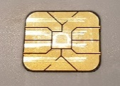

[This Photo](http://security.stackexchange.com/questions/123884/can-i-repair-a-cut-through-credit-card) by Unknown Author is licensed under [CC BY-SA](https://creativecommons.org/licenses/by-sa/3.0/)